Multimedia Assessed Project

(Web page development) Report

198735

**MComp Computer Science (with an industrial placement year)**

**Introduction to Multimedia**

**13/11/2018**

# Contents

## Introduction

### 1.1 Introduction to project

### 1.2 Introduction to report

### 1.3 Project objectives

## 2.0 Design and Development

### Website Design and Development

#### The homepage

#### Links to other pages

#### The Greeting page

#### The reshuffle and Hobbies Section

#### The Coursework section

#### The Animation section

#### Logo revamp

#### The de-shuffle

#### The navigation development

#### The nebula slideshow

#### Final touches

### Animation Design and development

#### The basics

#### The first beats

#### The first complex animation

#### The repetition

#### The disappearing objects

#### The play and replay button

#### 2.2.7 The interactive component

## 3.0 Conclusion

### 3.1 Website

### 3.2 Animation

### 3.3 Final thoughts

## 4.0 Sources

### 4.1 Navigation header and Icon

### 4.2 Homepage

### 4.3 Greeting page

### 4.4 Hobbies page

### 4.5 Coursework page

### 4.6 Animation page

# Introduction

## Introduction to the project

This project consists of designing and building a website from scratch. The specification says that the website must have 5 pages; a homepage (which contains introductory material), a video greeting page (which contains a video clip introducing the site), a hobbies page (which contains a description of hobbies), a coursework page (which contains this report, the work from labs 3 part 3 and any other coursework relevant to this project), and finally a vector animation page with sound using JavaScript.

## Introduction to the report

This report encompasses the work that was undertaken to complete the webpage development project for the module; Introduction to Multimedia. Outlining the design and the development of the website, and the animation on the website the report also includes a conclusion that sums up the project, and the references used in my project. The project goals are outlined below, and it is shown that the project achieves these goals within the conclusion.

## Project objectives

### Website objectives

* + - 1. A 5-page website with the correct content on each page
      2. Well laid out site with suitable navigation bar
      3. The navigation bar stays at the side of the page and can be hidden
      4. A name for the site on the navigation bar and in title of webpage
      5. A text introduction on the homepage
      6. An image on the homepage
      7. An embedded video clip that is less than 10 secs on the second page
      8. A description of hobbies with relevant pictures on hobbies page
      9. The project is embedded into the website on the coursework page
      10. Coursework from recent labs is embedded into the website on the coursework page
      11. A slideshow of Images on the homepage
      12. The background is twinkling stars that are randomly generated

### Animation objectives

* + - 1. Audio file starts when animation is played and is synced with animation
      2. Bitmap image in animation
      3. At least 2 animated vector objects in the scene
      4. Play and replay button
      5. Animation includes complex animation as well as simple animation
      6. Lasts for the whole of the audio file
      7. There is interactivity in the animation
      8. Beat detection in the animation

# Design and Development

## Website Design and Development

### The Home Page

Here is the home page after the first day of development of the website.

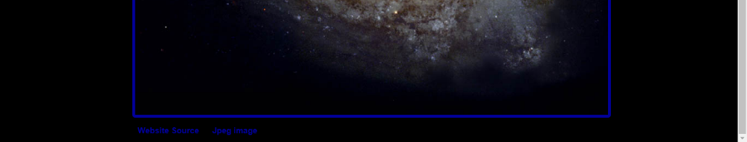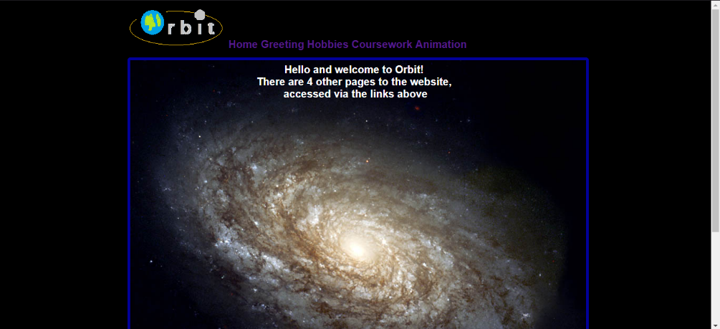The header did not scroll with the page at this stage. The header included the Orbit logo, made in the Windows Paint application, and 5 links to the other webpages (including this one) in the header. The free use image sat in the middle of the site with the text on top of the image. This was done because the image is so large that it takes up most of the page. In the footer, there are two links to the sources of the image, the site and the image itself.

(Sources used: 4.2.1, 4.4.1, 4.1.1)

### Links to other pages

The header contained links to the other pages on the website seen above next to the Orbit logo. Initially the links did not go to different html pages, as required by the specification, but this has now been resolved. The header didn’t scroll with the page, but this has also been corrected. (Sources used: 4.4.1)

### 2.1.3 The Video Page

Video had been added to the page as seen below, using HTML5, see below. Video looked good but needed some tweaking to sound good as the voice was a bit dreary. The page has also been shortened so that you don’t have to scroll, as this made no sense with the video. (Sources used: 4.3.1)



### 2.1.4 The reshuffle and Hobbies Page

Putting each section on a different html page was messy and lead to unnecessary code. The links at the top of the page now link to the corresponding header instead of another html document.

Borders were added to the different sections for them to be identifiable as was a scrollable header. This needed some work though as it didn’t work correctly when a link was clicked. E.g.

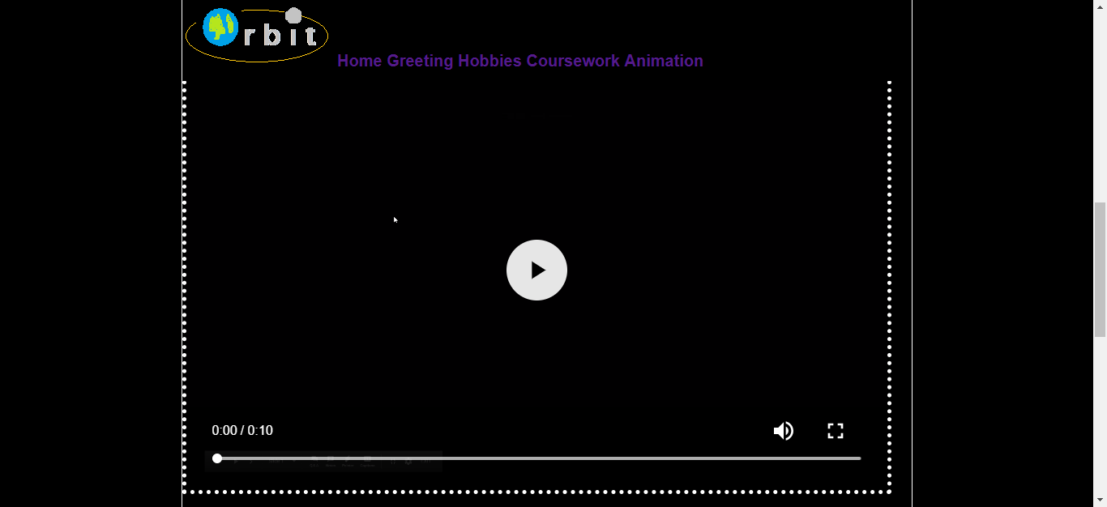

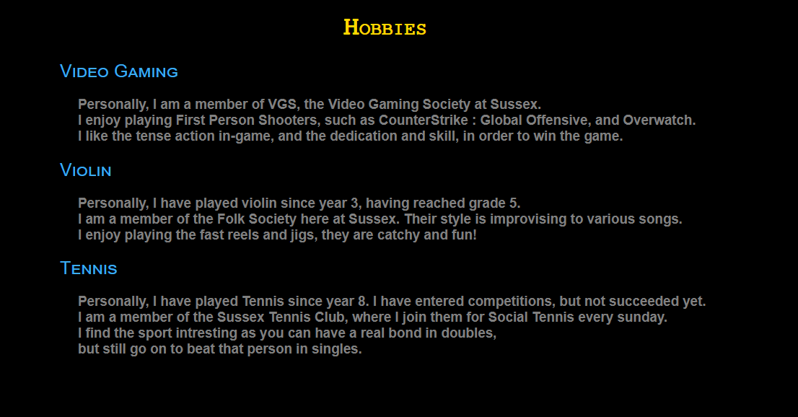

The Hobbies page text was added here using headers and CSS styling.

(Sources used: 4.1.3, 4.4.1, 4.4.2)

### 2.1.5 The Coursework Section and Header Re-structure

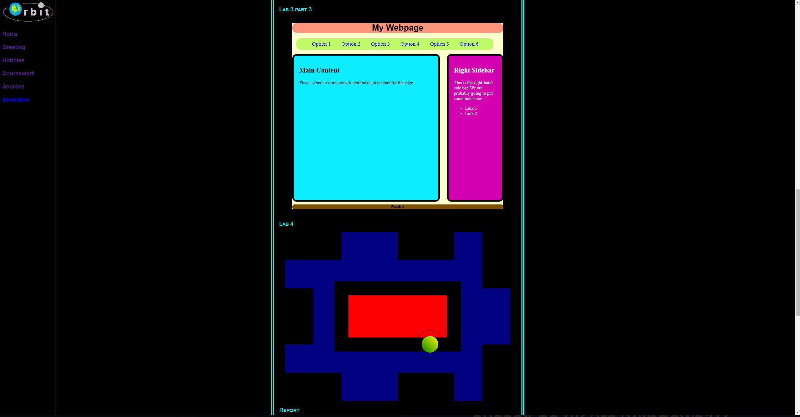

The coursework section was added with an embedded html document for Lab 3 part 3 and Lab 4. Also, an embedded Word Document is in this section for this document using Word Online, to show in the webpage.

An easy scrollable header allowed for easy access from any part of the website. The functionality of being able to hide this, was added later. (Sources used: 4.5.1)

### 2.1.6 Final Detailing and Animation section

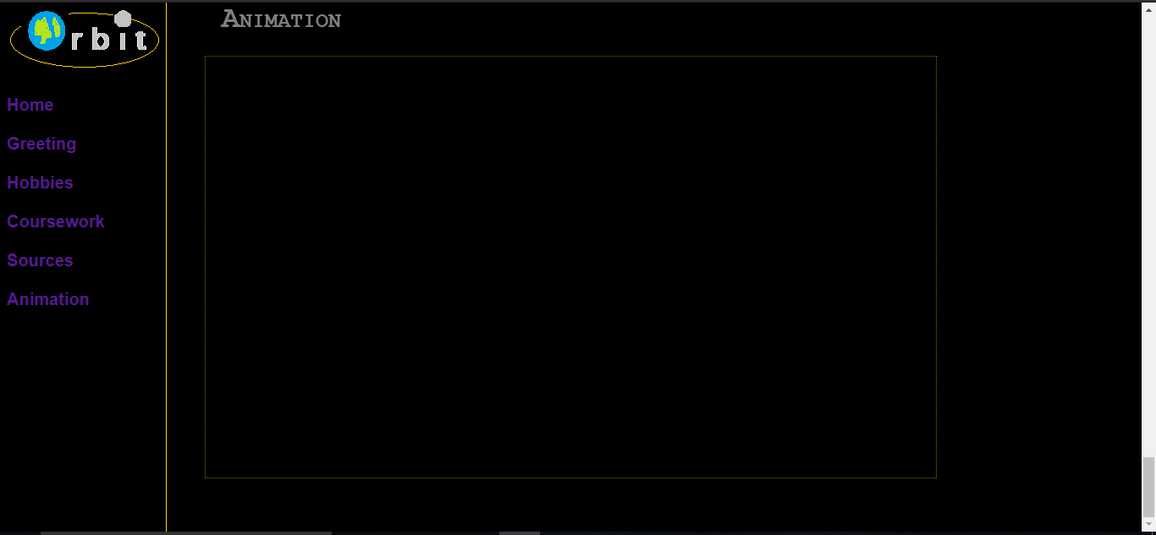

Following a Multimedia lecture where by the guidelines for building a good-looking website where laid out, the website needed a makeover once again to reduce the number of colours and randomness the user sees when navigating the site. Therefore, the website consisted of the main colours grey and gold, grey for headers and text, gold for page breaks and sub headers. The links on the website are still standard blue to avoid straying from convention.

The Animation section has been introduced at the bottom of the website page, with a link to directly take you to this section. The animation itself is embedded on the website using a different html document to display the actual animation. This made it easier to move the animation to the desired location on the page. Any more development on the website itself was cosmetic and used to make the page more interesting. (Sources used: 4.4.1, 4.4.2)

### 2.1.7 Logo Revamp

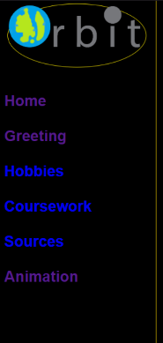 The logo was too pixelated and made the earth look terrible in the animation, (below), so required a photo-shop re-do. They are now crisp and sharp.

### 2.1.8 The de-shuffle

Looking at the mark scheme, even though one page seemed a good idea at the time, the website did not work after the reshuffle above. The website is now on separate pages. (Sources used: 4.4.1)

### 2.1.9 The navigation development

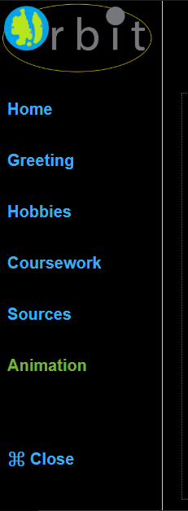 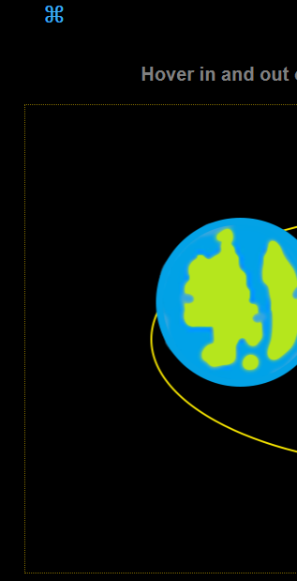

The screenshot on the left shows that each link is now coloured light blue, a similar colour to the logo, and when hovering over each link it changes colour to green, like the colour in the logo. The current page is highlighted in green, which is executed in JavaScript.

JavaScript is used to animate the navigation header on closing and opening. Closing the navigation can be done by clicking the close link. Opening the navigation can be done by clicking the similar symbol that appears on the current page, once the navigation is closed. Opening and closing uses different JavaScript code to operate, due to the navigation not animating on opening, so this uses a constantly changed length up to the original length, to simulate the animation. This unfortunately shows up slightly differently in Firefox and Chrome with Firefox being smoother than Chrome. (Sources used: 4.1.2, 4.1.4, 4.1.5, 4.1.6, 4.1.7, 4.6.13)

### 2.1.10 The nebula slideshow

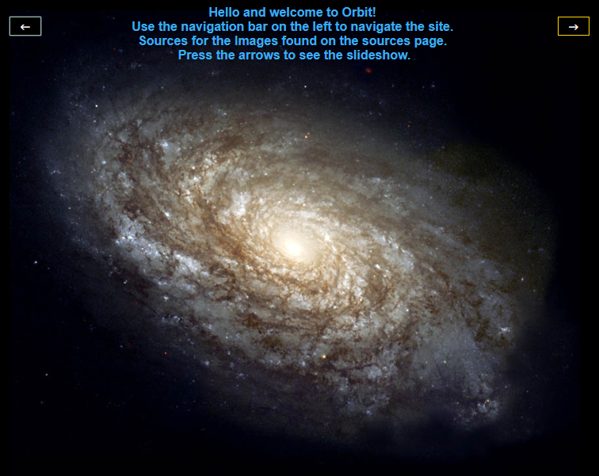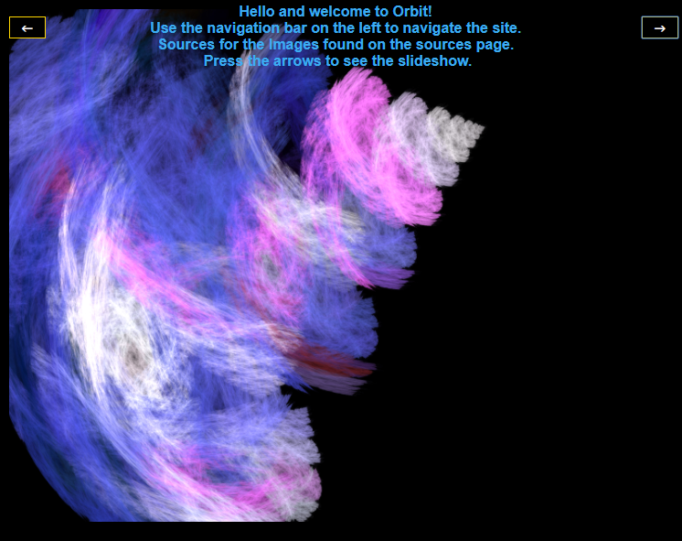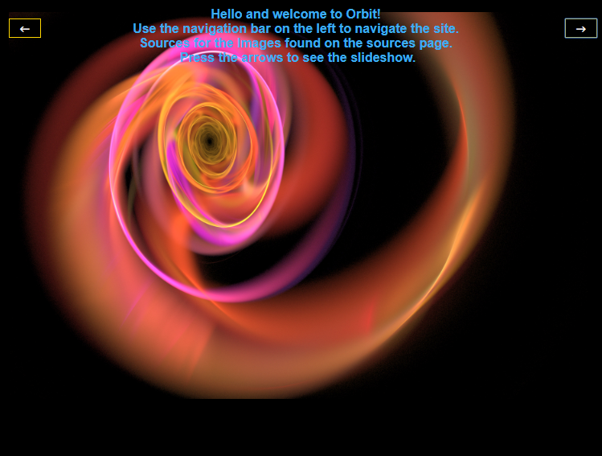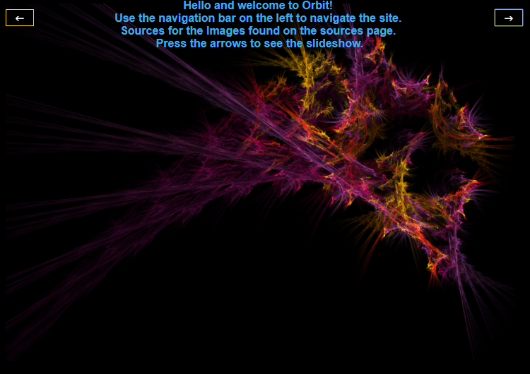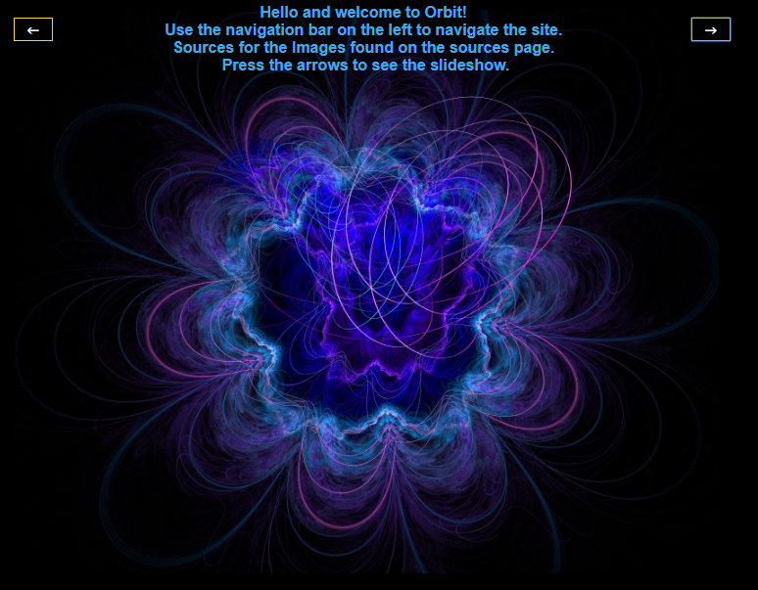

On the home page, instead of just the milky way image, the user can now see a slideshow of nebula images by pressing the left and right buttons, these images also have free use with attribution. This uses JavaScript to change the source of the image tag, and a case statement to change the source to the appropriate image when the index variable becomes too large or small, it reassigns the value to either the first or last image in the slideshow. (Sources used: 4.2.2, 4.2.3, 4.2.4, 4.2.5)

### 2.1.11 Final touches

This report will be changed to be pdf once finished and embedded into the website to avoid an embedded word document, which could be edited after the deadline.

A new video has been produced and embedded into the website with the improved Orbit logo. (Sources used: 4.5.1, 4.3.1)

## Animation Design and development

### The Basics and First Shapes

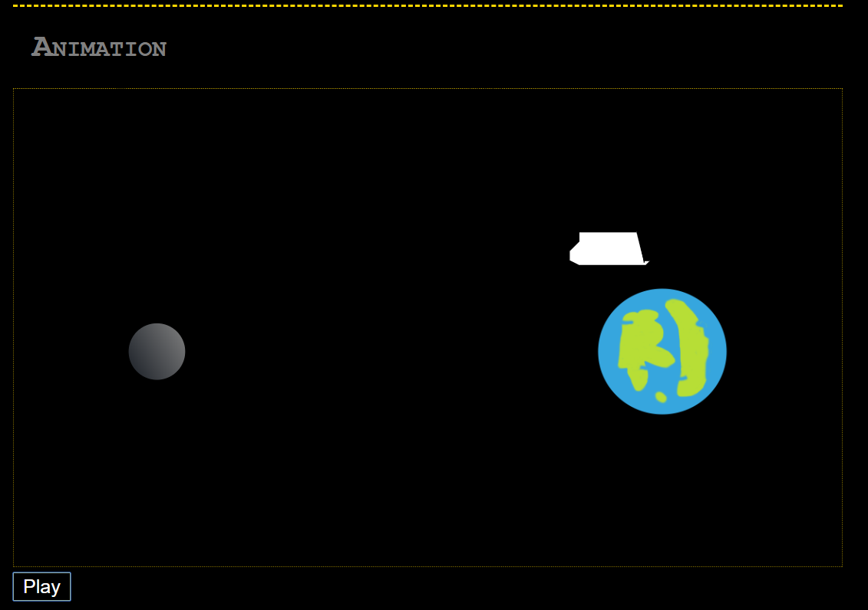

The animation progressed to a nice conclusion. It has a canvas which is marked out by a dotted border and a play button that starts the animation and audio. This allows the paper.circle to appear (the grey circle), which is the moon and the PNG Image of the Earth appears on beat. At this stage the version of the space shuttle was in development, which was created using paper.path, and was later updated. (Sources used: 4.6.1, 4.6.3, 4.6.4, 4.6.6, 4.6.9, 4.6.5)

### The First Beats and Space Shuttle completion

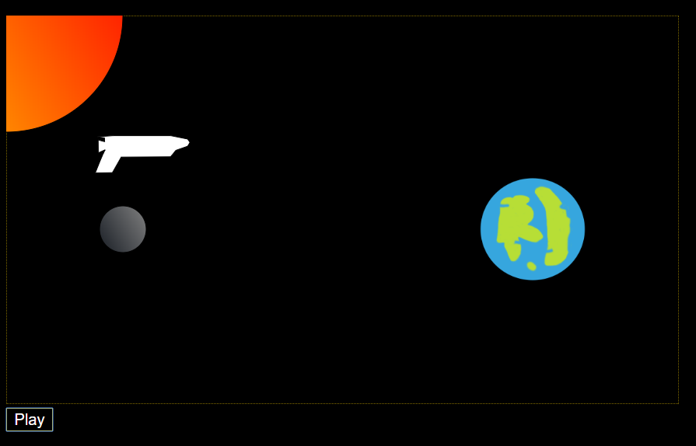

The animation improved rapidly. Each object; shuttle, earth, moon and sun, appear on the first 4 beats of the music track. The shuttle is made using paper.path, but using the nodes from a SVG file created in Inkscape. This allowed the accurate drawing of the space shuttle instead of trying to guess where the nodes should go. The shuttle at this stage flew from the earth to the moon then rotated 180 degrees. This wasn’t meant to happen but resulted from inexperience in the use of complex transformations, using t100,0 and r90, 0,0 , the translate and rotate functions under element.translate. (Sources used: 4.6.3, 4.6.8)

### The first complex animation

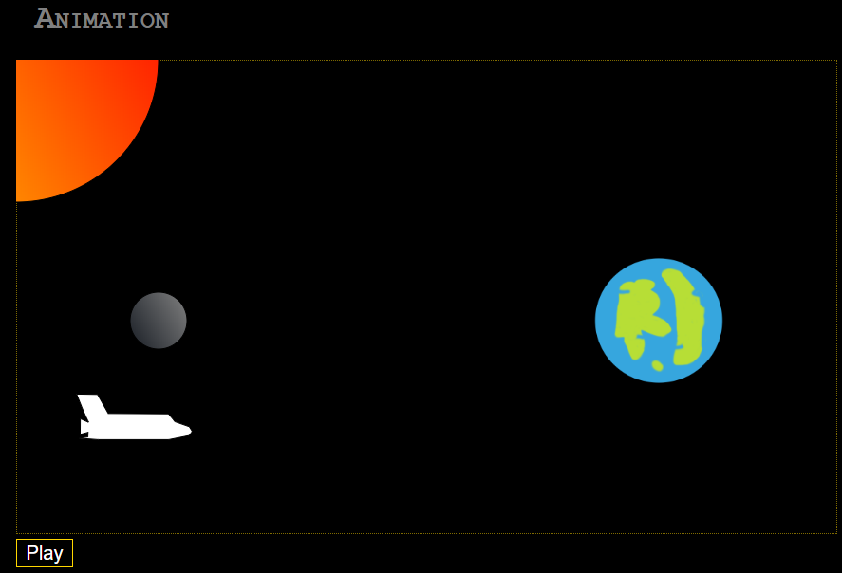

The shuttle goes from the position in the last section around the moon in a circular arc, using the transformation c, and scales itself so that it flips itself to be the right way around to go back towards the Earth, using the transformation s. (Sources used: 4.6.3, 4.6.14, 4.6.12)

### The repetition of the animation

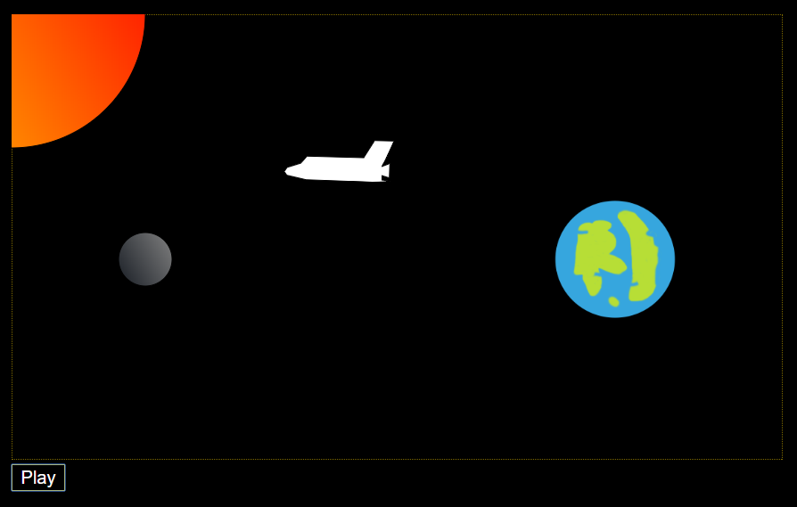

The shuttle uses the code from the Earth to the moon as seen above, to move from the moon to the Earth, and similar code to then curve round the Earth, and flips itself back again. It then, as seen in the picture, goes back to the moon, and curves around it again. The sun also changes shade on each beat. In this image it is orange-red, the next it is red-orange etc. (Sources used: 4.6.3, 4.6.10, 4.6.14)

### The disappearing objects

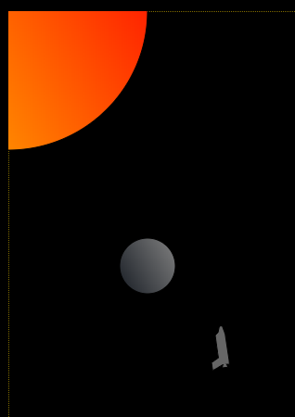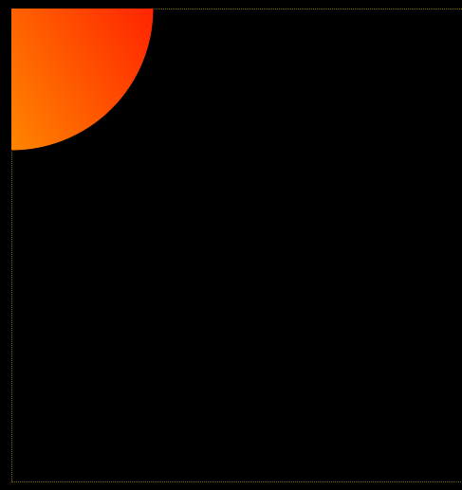

The Shuttle curves round the moon again, but this time it decreases in size as well as curvature, to ‘land’ on the moon and then disappears. In the last seconds of the mp3 file, there are beats similar to the start of the mp3 file. After the shuttle disappears so do the moon then the earth on beat, and as the last note in the mp3 is sustained the sun slowly decreases to nothing. (Sources used: 4.6.3, 4.6.14)

### Play button and Replay button

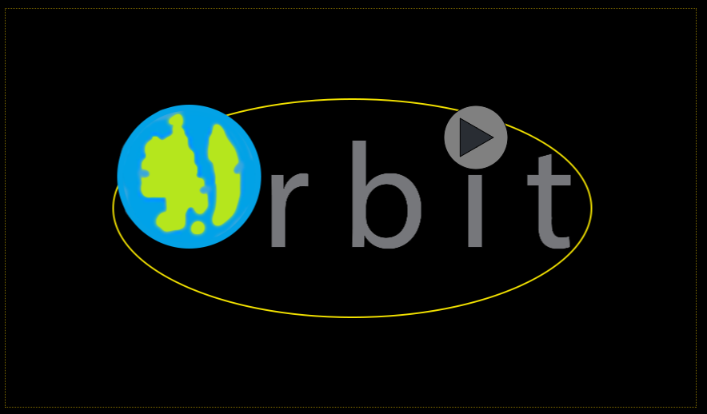

Dissatisfied with the play button, the animation now has an implemented path object preforming the same action. The logo is behind the path object, giving the impression that the play button is the moon. When hovered over the play button inverts its colours. The screenshot above shows the play button that is shown at the start and end of the animation, allowing the user to watch the animation as many times as they like. (Sources used: 4.6.3, 4.6.2, 4.6.8)

### 2.2.7 Interactive Component

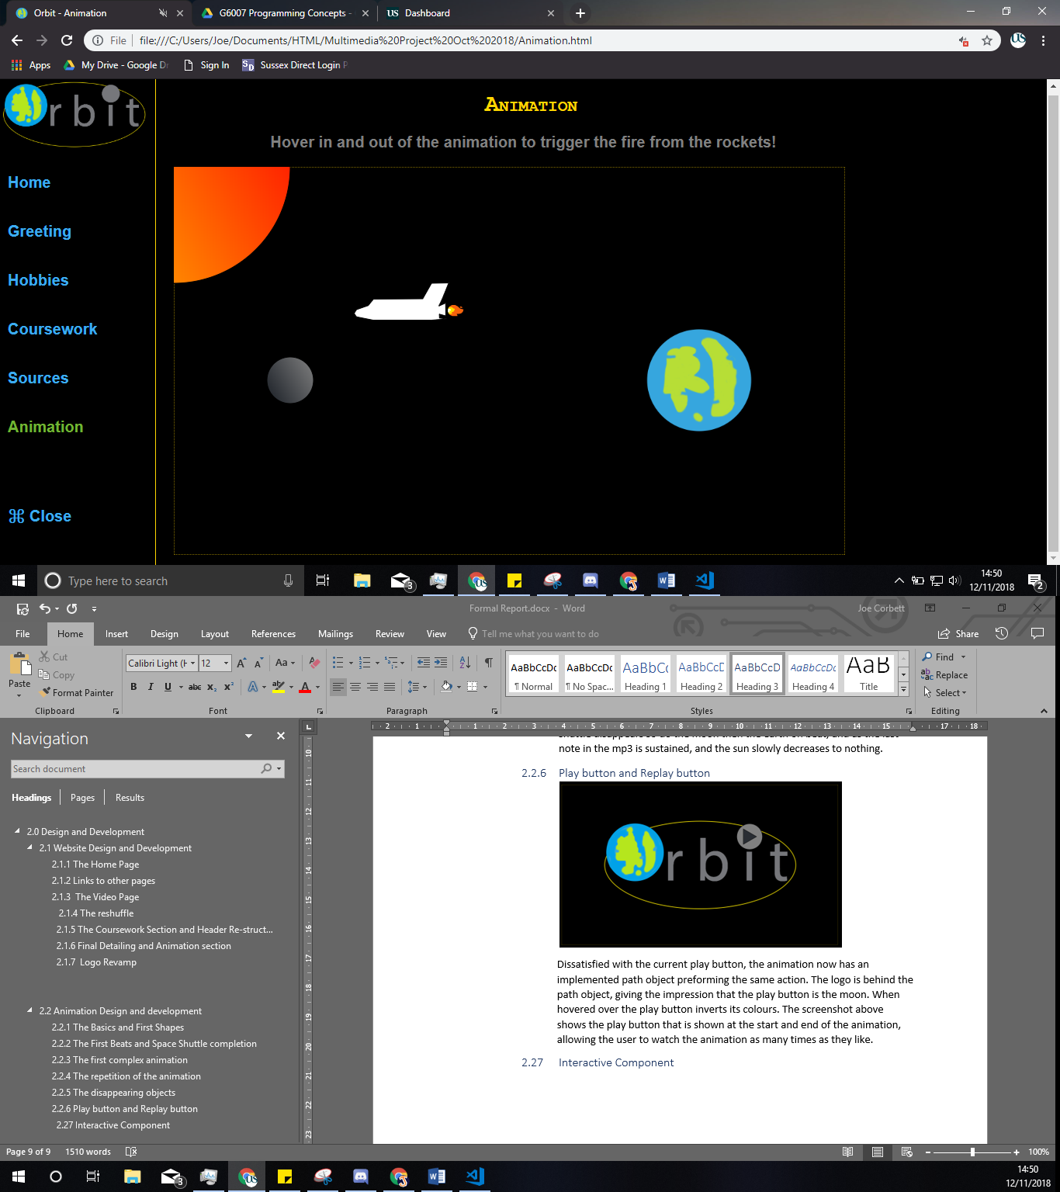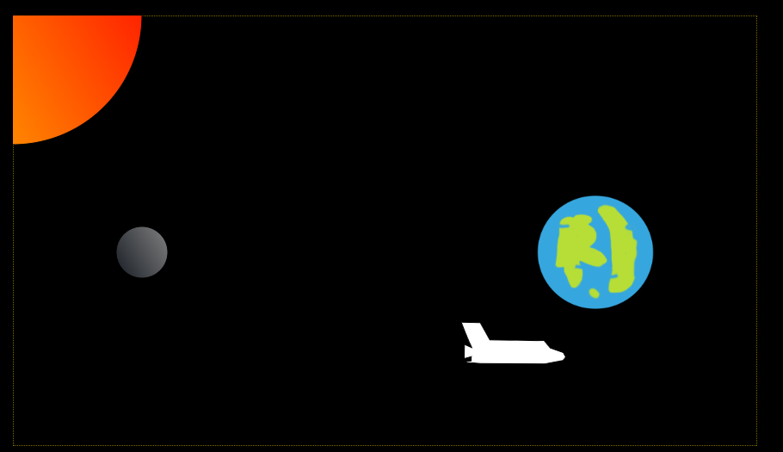The screenshots show the fire emoji (“🔥”), exiting out the back of the shuttle like flames exit the rockets in real life. When the user moves their mouse off the background of the animation, the fire slowly dies out from behind the shuttle. If the user moves their mouse back again, the fire comes back. The animation has a helpful explanation above it to tell the user this. (Sources used: 4.6.11, 4.6.3, 4.6.7, 4.6.2)

# 3.0 Conclusion

## Website

Firstly, the website went well, even though the writer has very little experience of using HTML and CSS, apart from the labs, at start of this project.

To show that the website achieved the objectives at the start, this conclusion confirms the following:

* 1.3.1.1 - The website does has at least 5 pages (6 in total), with the correct content;
* 1.3.1.2 - The website has a suitable navigation bar, and is laid out in an appropriate manner;
* 1.3.1.3 - The navigation bar stays at the side of the page, due to it being on top of the content, and can be hidden by the links;
* 1.3.1.4 - The name of the site is Orbit, and is a PNG file on the navigation bar, the title also includes the name i.e. “Orbit – Home”;
* 1.3.1.5 - There is a text introduction on top of the image on the homepage;
* 1.3.1.6 - There is an image on the homepage;
* 1.3.1.7 - There is a video clip on the greeting page, which can be played paused etc;
* 1.3.1.8 - There is a description of the hobbies, but unfortunately no relevant pictures due to a lack of time;
* 1.3.1.9 & .10 - The project, and coursework from recent labs are all embed on the coursework page;
* 1.3.1.11 - The homepage has a slideshow of images, transition through using buttons;
* 1.3.1.12 - The website doesn’t have a background that uses JavaScript, it’s just plain black.

Overall, only two objectives were not achieved; most of the criteria having been met, so the website was successful, although improvements could still be made.

## 3.2 Animation

Secondly, the animation went superbly, considering the relative inexperience of the writer. Achievements of the objectives are confirmed here:

* 1.3.2.1 - The audio file does start when the animation is played, and the shuttle switches direction on every new beat in the audio file;
* 1.3.2.2 - There is the icon for Orbit in the animation (the earth), and the logo for orbit at the start and end of the animation;
* 1.3.2.3 - The shuttle and the sun are both animated at the same time, along with the moon and play button at the start and end of the animation;
* 1.3.2.4 - There is a play button at the start of the animation, and appears after each iteration of the animation, so acts as a replay button;
* 1.3.2.5 - The simple animation includes the colour change of the sun and change in size of the planets at the start and end of the animation. The complex animation occurs for the shuttle and the fire behind it as they use transforms to animate around the planets;
* 1.3.2.6 - The first animation is at the start of the file. The last animation is on the last beat of the file;
* 1.3.2.7 - The fire coming out the back of the rocket can be controlled by the user;
* 1.3.2.8 – There is very little beat detection, the sun changes on every significant beat, but other than that the animation doesn’t have beat detection.

Overall, only one objective was not met. Therefore, the animation is a success, but the last objective could be implemented in the future.

## 3.3 Final thoughts

On a final note, the website could be improved with pictures on the hobbies page and a JavaScript background. The animation could be improved with advanced beat detection. The website looks the same in Firefox and Chrome, Opera and Edge apart from the video interface and navigation open sequence (This is only different in Firefox). Internet Explorer doesn’t show the Icon image in the tab, other than that the website is identical.

# 4.0 Sources

## 4.1 Navigation header and icon in tab

4.1.1 Perłakowski, M (2016) [*How to add a browser tab icon (favicon) for a website?*](https://stackoverflow.com/questions/4888377/how-to-add-a-browser-tab-icon-favicon-for-a-website) Available at: <https://stackoverflow.com/questions/4888377/how-to-add-a-browser-tab-icon-favicon-for-a-website> (Accessed 15 October 2018)

4.1.2 W3schools (No date) *How to create collapsing sidebar.* Available at: <https://www.w3schools.com/howto/howto_js_collapse_sidebar.asp> (Accessed 9 November 2018)

4.1.3 rahul (2010) *How to make a <div> appear in front of regular text/tables.* Available at: <https://stackoverflow.com/questions/2316015/how-to-make-a-div-appear-in-front-of-regular-text-tables> (Accessed 24 October 2018)

4.1.4 basheer, A (2017) *CSS - Set parent's height to 0 but child div still show.* Available at: <https://stackoverflow.com/questions/47977751/css-set-parents-height-to-0-but-child-div-still-show> (Accessed 9 November 2018)

4.1.5 W3schools (No date) *JavaScript HTML DOM Animation.* Available at: <https://www.w3schools.com/js/js_htmldom_animate.asp> (Accessed 10 November 2018)

4.1.6 W3schools (No date) *HTML DOM childNodes Property.* Available at: <https://www.w3schools.com/jsref/prop_node_childnodes.asp> (Accessed 10 November 2018)

4.1.7 W3schools (No date) *HTML DOM title Property.* Available at: <https://www.w3schools.com/jsref/prop_doc_title.asp> (Accessed 10 November 2018)

## 4.2 Homepage

4.2.1 W3schools (No date) *Position Text over an Image.* Available at: <https://www.w3schools.com/howto/howto_css_image_text.asp> (Accessed 15 October 2018)

4.2.2 W3schools (No date) *CSS Buttons.* Available at: <https://www.w3schools.com/css/css3_buttons.asp> (Accessed 31 October 2018)

4.2.3 W3schools (No date) *HTML DOM Image Object.* Available at: <https://www.w3schools.com/jsref/dom_obj_image.asp> (Accessed 31 October 2018)

4.2.4 W3schools (No date) *Image src Property.* Available at: <https://www.w3schools.com/jsref/prop_img_src.asp> (Accessed 31 October 2018)

4.2.5 W3schools (No date) *JavaScript Switch Statement.* Available at: <https://www.w3schools.com/js/js_switch.asp> (Accessed 31 October 2018)

## 4.3 Greeting page

4.3.1 W3schools (No date) *HTML5 Video.* Available at: <https://www.w3schools.com/html/html5_video.asp> (Accessed 18 October 2018)

## 4.4 Hobbies page

4.4.1 Canvas Sussex (2018) *Lab 3 part 3 – CSS and Divs*. Available at: <https://canvas.sussex.ac.uk/courses/4185/pages/lab-3-part-3-css-and-divs?module_item_id=283355> (Accessed 23 October 2018)

4.4.2 Google (No date) *Hexadecimal Colour Picker.* Available at: <https://www.google.com/search?q=hexadecimal+color+picker&rlz=1C1CHBF_enGB814GB815&oq=hexadecimal+color+&aqs=chrome.1.69i57j0l5.5485j0j7&sourceid=chrome&ie=UTF-8> (Accessed 31 October 2018)

## 4.5 Coursework page

4.5.1 Ioic17 (2014) [*Embed website into my site*](https://stackoverflow.com/questions/7890160/embed-website-into-my-site)*.* Available at: <https://stackoverflow.com/questions/7890160/embed-website-into-my-site> (Accessed 9 October 2018)

## 4.6 Animation page

4.6.1 Canvas Sussex (2018) *Lab 4 – 2D vector graphics and animation.* Available at: <https://canvas.sussex.ac.uk/courses/4185/pages/lab-4-2d-vector-graphics-and-animation?module_item_id=283356> (Accessed 16 October 2018)

4.6.2 W3schools (No date) *HTML DOM MouseEvent.* Available at: <https://www.w3schools.com/jsref/obj_mouseevent.asp> (Accessed 8 November 2018)

4.6.3 Baranovskiy, D (No date) *Raphaël Reference.* Available at: <http://dmitrybaranovskiy.github.io/raphael/reference.html> (Accessed 1 November 2018)

4.6.4 W3schools (No date) *Window setTimeout() Method.* Available at: <https://www.w3schools.com/jsref/met_win_settimeout.asp> (Accessed 1 November 2018)

4.6.5 Dawber, D (2009) *An Introduction to the Raphael JS.* Available at: <https://code.tutsplus.com/tutorials/an-introduction-to-the-raphael-js-library--net-7186>

(Accessed 2 November 2018)

4.6.6 Uri (2013) *Playing audio with JavaScript?* Available at: <https://stackoverflow.com/questions/9419263/playing-audio-with-javascript> (Accessed 1 November 2018)

4.6.7 sweetamylase (2013) *How to use Raphael .animateWith().* Available at: <https://stackoverflow.com/questions/15886606/how-to-use-raphael-animatewith> (Accessed 8 November 2018)

4.6.8 Packt (2013) *Features of Raphael JS.* Available at: <https://hub.packtpub.com/features-raphaeljs/> (Accessed 5 November 2018)

4.6.9 Doyle, M (2010) *The Joy of HTML5 Audio: Tips & Tricks for Easy Sound Embedding.* Available at: <https://www.elated.com/articles/html5-audio/> (Accessed 31 October 2018)

4.6.10 lonesomeday (2011) *Convert Boolean result into number/integer.* Available at: <https://stackoverflow.com/questions/7820683/convert-boolean-result-into-number-integer> 7/11

4.6.11 kirupa (No date) *Using Emojis in HTML, CSS, and JavaScript.* Available at: <https://www.kirupa.com/html5/emoji.htm> (Accessed 8 November 2018)

4.6.12 Stevens, M (2012) *Raphael JS Flipping Image.* Available at: <https://stackoverflow.com/questions/13974730/raphael-js-flipping-image> (Accessed 5 November 2018)

4.6.13 DVK (2011) *Implications of multiple <script> tags in HTML.* Available at: <https://stackoverflow.com/questions/4659409/implications-of-multiple-script-tags-in-html> (Accessed 10 November 2018)

4.6.14 Baranovskiy, D (No date) *Raphaël Animation demo.* Available at: <http://dmitrybaranovskiy.github.io/raphael/animation.html> (Accessed 5 November 2018)